

*DHHS Health Education Website*

SOFTWARE **PROJECT MANAGEMENT PLAN**

Version *<1.1>*

*02/25/2020*

**Group 3:**

Camryn Truban

Erin McLaughlin

Benjamin King

Patrick Hedquist

Nitesh Khakurel

UPDATE **HISTORY**

|  |  |  |  |  |  |
| --- | --- | --- | --- | --- | --- |
| **Version #** | **Implemented**  **By** | **Revision**  **Date** | **Approved**  **By** | **Approval**  **Date** | **Reason** |
| 1.0 | Camryn Truban  Erin McLaughlin  Benjamin King  Patrick Hedquist  Nitesh Khakurel | 2/18/2020 |  | *<mm/dd/yy>* | *<reason>* |
| 1.1 | Camryn Truban  Erin McLaughlin  Benjamin King  Patrick Hedquist  Nitesh Khakurel | 2/25/2020 |  |  |  |
|  |  |  |  |  |  |
|  |  |  |  |  |  |

***Preface***

Results of a recent study commissioned by the US Dept of Health and Human Services (DHHS) reveal that teens today are more likely to develop a sustained interest in a healthy, active lifestyle if they are provided with some type of technology-based “game-like” tool to stimulate their interest in the areas.

Based on the results of this study, along with rapidly increasing public interest in health, the DHHS has made the decision to form the Healthy Teen Healthy Life committee or HTHL. The goal of this committee will be managing the creation of a technology-based, gaming tool to meet this need. The HTHL made the decision to hire Subject Matter Experts (SMEs) from various related industries including fitness, teaching, medical, health/nutrition and technology, to determine the initial needs of the product and lead this effort to fruition.

After months of planning the HTHL committee has secured funding for creation of a “revolutionary gaming-based website that educates while it stimulates young minds.” Initially the committee has decided to focus on high school aged teens and mobile devices however they have made it very clear that their final vision for the system is that it caters to children of all ages and able to be used on all popular devices.

**TABLE OF CONTENTS**

**INTRODUCTION** **3**

PROJECT OVERVIEW 3

PROJECT DELIVERABLES 4

EVOLUTION OF THE SPMP 4

REFERENCE MATERIALS 4

DEFINITIONS AND ACRONYMS 4

**PROJECT ORGANIZATION** **4**

PROCESS MODEL 4

ORGANIZATIONAL STRUCTURE 4

ORGANIZATIONAL INTERFACES 5

PROJECT RESPONSIBILITIES 5

**MANAGERIAL PROCESS** **5**

MANAGEMENT OBJECTIVES AND PRIORITIES 5

ASSUMPTIONS, DEPENDENCIES, AND CONSTRAINTS 5

RISK MANAGEMENT 5

STAFFING PLAN 6

MONITORING AND CONTROLLING MECHANISMS 6

**TECHNICAL PROCESSES** **6**

METHODS, TOOLS, AND TECHNIQUES 6

SOFTWARE DOCUMENTATION 6

PROJECT SUPPORT FUNCTIONS 6

**DESCRIPTION OF WORK PACKAGES** **7**

WORK BREAKDOWN STRUCTURE (WBS) 7

# 

# **INTRODUCTION**

## PROJECT OVERVIEW

The purpose of the project management plan is to outline necessary steps and procedures for creating software for the U.S. DHHS that includes a website with an educational game targeted at a teenage audience.

The intended audience of the DHHS Health Education Website PMP is all project stakeholders including the project sponsor, senior leadership and the project team.

## PROJECT DELIVERABLES

Deliverable #1 - Requirements

Due: Monday 2/17 @ 5PM

Deliverable #2 - Use Cases

Due: Monday 2/17 @ 5PM

Deliverable #3 Part One - Repo Setup

Due: Friday 2/21 @ Midnight

Deliverable #3 Part Two - SPMP

Due: Monday 2/24 @ 5PM

Mid-semester Group Project Status Presentations

Due: Monday 3/23 @ 5 PM

All Assignments

Due: Monday 4/27 @ 11:59 PM

Final Project Presentation

Due: Monday 5/18 @ 7:00 PM

## EVOLUTION OF THE SPMP

R1.Estimating time & risks - If time is not properly allocated, and deadlines are getting close to being missed and the project contents are rushed, or the deadline is missed all together.

R2.Change of requirements - If the vision of the client changes throughout the project and either changes one of the requirements previously, or adding additional requirements throughout the project life.

R3.Unforeseen circumstances - If any members of the project are unable to complete tasks, someone becomes ill, or drops out of the project all together.

R4.Unclear specifications - Incorrect project initiation, specifications may be unclear and need more details for the project team to complete their tasks.

R5.Neglecting design - Developers may attempt to save time and neglect design. This may cause issues with the traceability, and or functionality of the project.

R6.Technical risks - Changes in technology, and the apparent inability for certain tools to adapt to the project needs may cause a loss of time spent on the project.

## REFERENCE MATERIALS

## DEFINITIONS AND ACRONYMS

SPMP: Software Project Management Plan

DHHS: Department of Health and Human Services

HTHL: Healthy Teen Healthy Life committee

SME: Subject Matter Expert

CI: Continuous Integration

# PROJECT ORGANIZATION

## PROCESS MODEL

Agile project management. This model helps to best accommodate the changes in requirements so that the design can be updated accordingly.

## ORGANIZATIONAL STRUCTURE

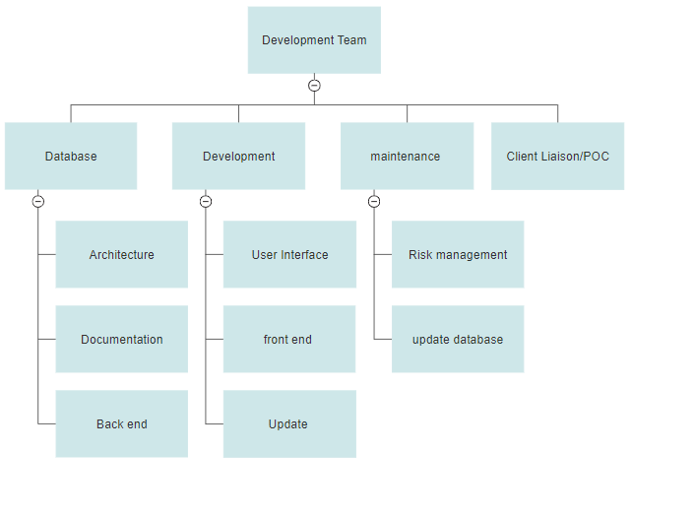

## ORGANIZATIONAL INTERFACES

Visual Paradigm Online (<https://online.visual-paradigm.com/>) software used to create use cases and WBS.

Hosting services.

## PROJECT RESPONSIBILITIES

Point of Contact - Contacts client, and updates them on progress of project. Ensures the project team is informed on any updates on the requirements for the project. (Erin McLaughlin)

Developer - Producing clean, efficient code based on specifications. Testing and deploying programs and systems, and fixing and improving existing software.(Camryn Truban, Benjamin King, Patrick Hedquist, Nitesh Khakurel)

# MANAGERIAL PROCESS

## MANAGEMENT OBJECTIVES AND PRIORITIES

1. Complete weekly deliverables on time
2. Detailed documentation
3. Simplify tasks and divide work equally
4. Meet weekly in YR303 at 3:15pm

## ASSUMPTIONS, DEPENDENCIES, AND CONSTRAINTS

Assumptions:

1. All members of the group will be available during meeting hours
2. All members of the group will have access to all documents and project data
3. All devices and programs will work properly

Dependencies:

1. word database for game must be created before game can be finished
2. user interface for website must be created before implementing game

Constraints:

Time:

1. Weekly Deliveries due @5pm every Monday
2. Final product due @ Midnight on 4/27/2020
3. Planning goals, delegating tasks, and acquiring equipment/software
4. Scheduling

Scope:

1. Providing clear documentation of progress/changes
2. Managing, reviewing, and implementing changes

Cost:

1. Cost needs to be minimal, goal of $0.00 spent but no more than $50.00

## RISK MANAGEMENT

R1. Camryn, Patrick, Nitesh will allocate time on weekends to complete unfinished tasks

R2. Have a formal meeting to restructure the project plan

R3. Review of priorities, and redelegation and tasks if anyone were to drop out of the project.

R4.Routinely update customers on the status of the project, and ensure that any assumptions that are made are appropriate for the requirements for the project.

R5.Delegate a person in the project to check that all of the projects substance meets to standards and requirements so that the project can make effective use of CI.

R6.Analyze all possible risks that may occur, and ensure that they are prioritized. Ensure all members are aware of these risks, and create contingency plans for these possible risks.

## STAFFING PLAN

Five people have access to conduct, run and maintain the project via GitHub.

## MONITORING AND CONTROLLING MECHANISMS

PMP updates, Project documentation update, GitHub commits.

# TECHNICAL PROCESSES

## METHODS, TOOLS, AND TECHNIQUES

Methods:

Agile project management. This model helps to best accommodate the changes in requirements so that the design can be updated accordingly.

Tools:

* Agile
* Wordpress
* Host (GoDaddy.com or x10hosting.com)
* Eclipse (JavaScript)
* Google API
* Github

Techniques:

* Use java to create the game
* Use HTML (Wordpress) to develop the website
* https://www2.cdc.gov/cdcup/library/templates/cdc_up_project_management_plan_template.doc

## SOFTWARE DOCUMENTATION

All changes will be documented using the Update History form located on page 1. This form will require the developer to fill out detailed information about the changes they have made. The developer must seek approval before the deployment of the updated version. Once approval has been given the developer, as well as the approver, will discuss the changes with the client. Once the client is satisfied with the new update the developer will require them to sign the document located in Appendix A. This will show that all persons of interest have verified and are aware of the new changes being implemented in the project.

## PROJECT SUPPORT FUNCTIONS

Quality assurance:

* Control activities of the project
  + Update history
  + Appendix A
* Peer-to-peer reviews
  + Verify work of an individual is rational and will not crash the system
  + Verify developers have appropriate experience with the tool and techniques being used
* Software Testing
  + Screen for bugs in the system before deployment
  + Deploy beta testing to evaluate user experience and document issues they may encounter

Configuration management plan:

The configuration management plan (CMP) is to document and inform project stakeholders about CMP within a project, what CM tools will be used, and how they will be applied by the project.

Verification and validation plan:

Utilizing the following forms to ensure verification and validation of the project.

* Update History form
* Appendix A form

# DESCRIPTION OF WORK PACKAGES

## WORK BREAKDOWN STRUCTURE (WBS)

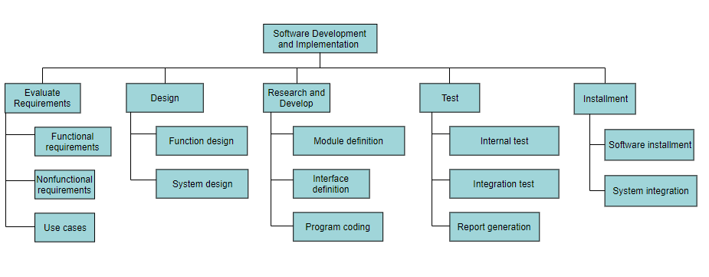

**Appendix A: Project Management Plan Approval**

The undersigned acknowledge they have reviewed the DHHS Health Education Website **Project Management Plan** and agree with the approach it presents. Changes to this **Project Management Plan** will be coordinated with and approved by the undersigned or their designated representatives.

|  |  |  |  |
| --- | --- | --- | --- |
| Signature: |  | Date: |  |
| Print Name: |  |  |  |
| Title: |  |  |  |
| Role: |  |  |  |

|  |  |  |  |
| --- | --- | --- | --- |
| Signature: |  | Date: |  |
| Print Name: |  |  |  |
| Title: |  |  |  |
| Role: |  |  |  |

|  |  |  |  |
| --- | --- | --- | --- |
| Signature: |  | Date: |  |
| Print Name: |  |  |  |
| Title: |  |  |  |
| Role: |  |  |  |

**APPENDIX B: REFERENCES**

The following table summarizes the documents referenced in this document.

|  |  |  |
| --- | --- | --- |
| **Document Name and Version** | **Description** | **Location** |
| *<Document Name and Version Number>* | *[Provide description of the document]* | *<URL or Network path where document is located>* |